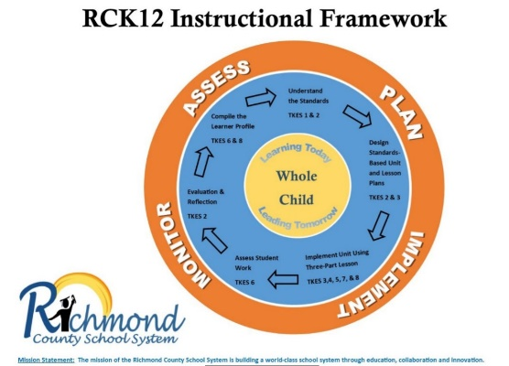

School: __________________________________________

Teacher: _________________________________________

Assessment: ______________________________________

Date: ____________________________________________

**ASSESS**

Step 1: Understand the data source.

What do the terms in the data mean?

What special characteristics (or “quirks”) about the assessments should we understand prior to analyzing the data?

Step 2: State the facts, identify patterns, and reflect on data.

The facts:

|  |  |  |
| --- | --- | --- |
| Successful Standards (greater than or equal to 70%) | Mixed Results Standards (between 50% – 70%) | Unsuccessful Standards (less than or equal to 50%) |
|  |  |  |
|  |  |  |
|  |  |  |
|  |  |  |

Identify patterns.

|  |  |
| --- | --- |
| Major Patterns of Class Strengths | Major Patterns of Class Needs |
| What knowledge and skills are the most important overall class strengths? | What knowledge and skills are the most important overall class needs? |

Reflection:

What instructional factors might have contributed to the patterns of student performance on these assessments?

### PLAN

Step 3: Plan differentiated instruction based on data.

* What steps will you take (such as scaffolding or re-teaching using a different strategy) to address the patterns of class needs? How and when will we re-assess to determine progress?
* How will the re-teaching of these standards be incorporated into the content? When?
* What strategies and materials will you use to re-teach?
* What product/products will you collect to measure increased student mastery of the standards?

|  |  |  |  |  |
| --- | --- | --- | --- | --- |
| Students Who Excelled | In-Class Enrichments to  Implement |  | Students Who Need  Additional Assistance | In-Class Interventions to  Implement |
| Which students are ready for enrichment and more independent work? | What in-class enrichments will you implement for these students?  What assistance and resources will you need to implement the enrichments?  Who will be responsible for implementing the enrichments?  What data will you use to deter- mine the success of the enrichments? |  | Which students will need some additional assistance to attain the targeted knowledge and skills?  Which students will need the most additional assistance to attain the targeted knowledge and skills? | What in-class interventions will you implement so that these students will attain the targeted knowledge and skills?  What assistance and re- sources will you need to implement the interventions?  Who will be responsible for implementing the interventions?  What data will you use to determine the success of the interventions? |

### IMPLEMENT and MONITOR

Step 4: Next Steps

* + When will you review the data again to determine the success of the enrichments, interventions, and instructional changes?
  + Based on reflection on the past instruction/re-teaching and the current levels of student performance, as shown by the data, how will you improve future instruction to increase the learning of all students?

**NOTES**